Instrument Number 4 |  |  | Term 2 2022
Student Name |  | Handout Date (Week Beginning) |  | 30/05/2022
Teacher Name |  | Interim Check Date |  | 6/06/2022
Unit Number/Name | Earth Science and Ecology | Rough Draft Date |  | 9/06/2022
 |  | Due Date |  | 16/06/2022

Assessment Technique | Assignment
Time/Length | 3 Weeks
Assessment Conditions | Summative
Seen/Unseen | Seen
 | Materials handed out prior to assessment? | No ☐ | Yes ☒ | Conditions
 |  |  |  | Research Materials

Choose an item. | Grades
Science Understanding
Science Inquiry
Choose an item.

Differentiation: If assessment conditions have been adjusted details are provided below

Acknowledgement of assessment responsibility
I understand the consequences of plagiarism/cheating and confirm this is my own work.
Student Signature: | Date: ………………………………

Maroochydore State High School
Standards Matrix for Year 9 Science Ecology and Earth Science

Assessable Elements | A | B | C | D | E
Science Understanding |  | Part C  Comprehensively explained the effect of the introduced species on an Australian ecosystem: | Part A and B  Listed and described at least one Structural, one Behavioural, and one Functional adaptation | Part A and B  Listed and described Structural, Behavioural, or Functional adaptation. | Explained which of the terms (invasive, introduced and/or pest species) matches their species.
Science Understanding |  | Included a diagram of an Australian food web, correctly labelled and used it to correctly explain the influence of the introduced species. | Explained the 3 different types of adaptations. | Explained one of the 3 different types of adaptations.
Science Understanding |  | Research provided accurate information on when, where, why the species was introduced | Comprehensively described the animal using all the criteria outlined and included a diagram/picture of the animal. | Described the animal using some of the criteria outlined and included a diagram/picture of the animal.
Science Understanding |  | Identified where it is found, population size and control measures. | (Scientific name, appearance, size, habitat, food source, predators, reproduction, life span, unusual features) | (scientific name, appearance, size, habitat, food source, predators, reproduction, life span, unusual features)
Science Inquiry |  | Presented in correct and accurate scientific language and representations in a sophisticated format. | Presented information using scientific and everyday language in an appropriate format | Used everyday language and representations when communicating findings and ideas to audiences

Teacher feedback:

Introduction:
Since European settlement many species have been introduced into Australia. These introduced species range from the large (eg camel) to the microscopic (eg myxoma virus). Many species were introduced for a specific purpose while others were introduced by accident. It is evident today that many of these introduced species have had a major impact on our native flora, fauna and environment.

Task:
To present a case study of one species introduced to Australia. Completing your case study involves 5 steps
- Choose a species to do your case study.
- Task A
- Task B
- Task C
- Presentation of the parts you have completed. Your presentation may be in the form of a Power Point (*8 Slides), a poster (*A2) or a movie (*5 minutes). *guideline only

You are required to acknowledge sources used by including a bibliography in Harvard format.

- CHOOSING YOUR SPECIES
Choose one animal from the table below (If you know of another introduced species not listed, consult with your teacher before researching it.).
Every person in the class must choose a different introduced species.
Mammals |  | Fish | Birds | Other
Red Fox  Dromedary (Camel)  Water Buffalo  Feral Goat  Feral Cat  Brumby | Feral Donkey  Feral Pig  Feral Deer  Black Rat  Brown Rat  Ferret  House mouse | Carp  Brown Trout  Rainbow Trout  Tilarpia  Mosquitofish | Common Mynah bird  Common Pigeon  Eurasian Blackbird  Eurasian Skylark  Eurasian Tree Sparrow  House Sparrow | Common House Gecko  Western honey bees  European Wasps  Black-Striped Mussel  Asian Mussel  European Shore Crab  Northern Pacific Sea star  Fire Ants  Cane Toad
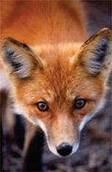
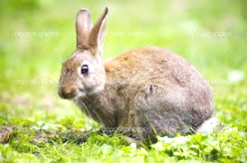
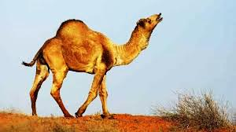

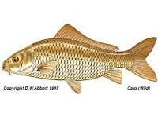
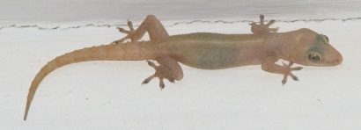
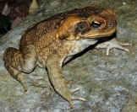
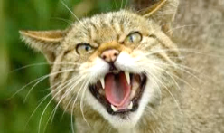

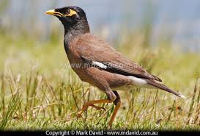
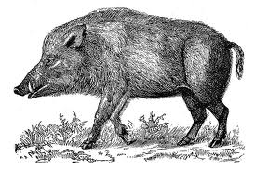

- Task A – This task provides a description of your chosen species.

- Decide which term/s (invasive, introduced and pest) matches your species and explain why.
- State the correct scientific name and scientific class of the species.
- Describe the appearance, size, habitat, food source, predators, reproductive characteristics, life span, and any additional and unusual features of your species. Include a clear picture
- Record of all sources used in your Bibliography

- Task B – This task explains the specific adaptations of your species.

- List the animal’s adaptations that help make it successful in Australia.
- Give an example from your list of each type of adaptation. (The three types of adaptation are: structural, behavioural, and physiological.)
- Each of your three adaptations should be accompanied by a two or three sentence explanation of how that adaptation provides an advantage for the animal in Australia.
- Record all sources used in your Bibliography

- Task C - This section describes the effect of the species within Australia

Present information on:

- When was the species introduced?
- Where was the species originally from?
- Where is the species found in Australia now (in your presentation include a map that shows where it is found)?
- Why was the species introduced into Australia?
- What is a reasonable estimate of the population of the species in Australia?
- What measures are currently being used to try to control the numbers of this species?
- Include a diagram of an Australian food web which the introduced species has become part of. Use this food web to answer the following question.
- Does your species have a positive or negative effect on the Australian environment? Provide evidence to support your opinion. The use of appropriate words to describe a food web (such as trophic level, competitor, consumer, producer, etc.) is an important part of your answer.

- Record all sources used in your bibliography

